SOCIAL MEDIA CONTENT FOR MEMBERS:
FEBRUARY 2025 – MAY 2025
Instructional copy: We have a suggested relevant timeframe. You can also post multiple times and re-write the descriptions to fit your needs.
Image, if Applicable  Full size images linked here | Relevant timeframe/Languages  Audiences | Summary/Suggested Post
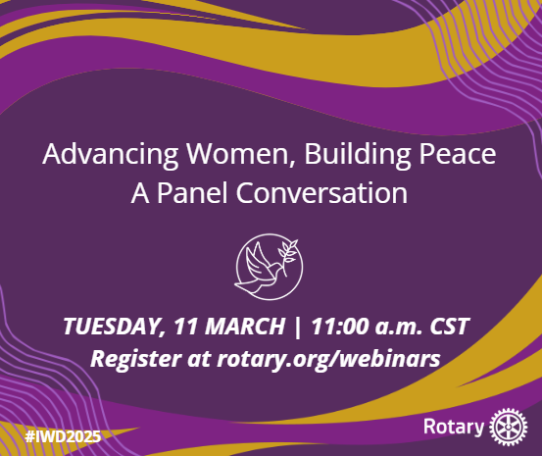 | Before 11 March  For: Members and general public | Continue the International Women’s Day celebration by joining us for the Advancing Women, Building Peace webinar. This panel discussion on Tuesday, 11 March, at 11:00 Chicago time (UTC−5) features speakers from around the world who will share how they contribute to peace in their communities, how Rotary is uniquely positioned to support their efforts, and how everyone can become peacebuilders. Register today and submit your questions. Everyone who registers will receive the webinar recording. https://rotary-org.zoom.us/webinar/register/WN_UIIHnyixS-GEKQ6PmPkKyg
 | 10-14 March  For: Members and general public | World Rotaract Week: TBD
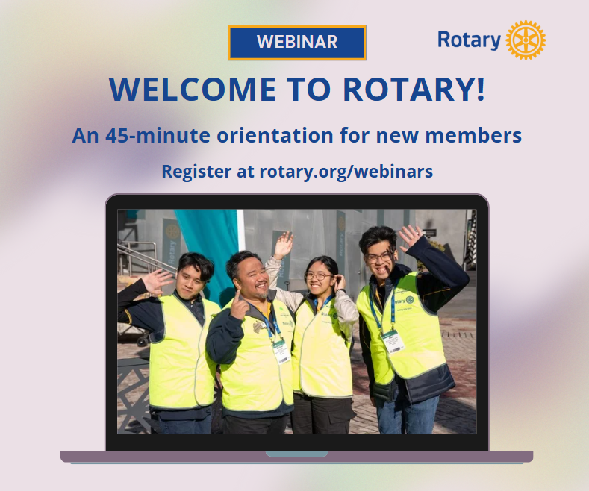 | Before 6 April  For: Members | We are so excited to welcome you to the incredible Rotary community. Did you know that when you joined your club, you also joined our global network of 1.2 million neighbors, friends, leaders, and problem-solvers? We truly see a world where people unite and take action to create lasting change – across the globe, in their communities, and in themselves – and we can’t wait to see how your journey unfolds.  Join us to learn about our mission, vision, and values, discover many ways you can get involved, and hear stories from current members to inspire your journey. https://my.rotary.org/en/learning-reference/webinars/upcoming
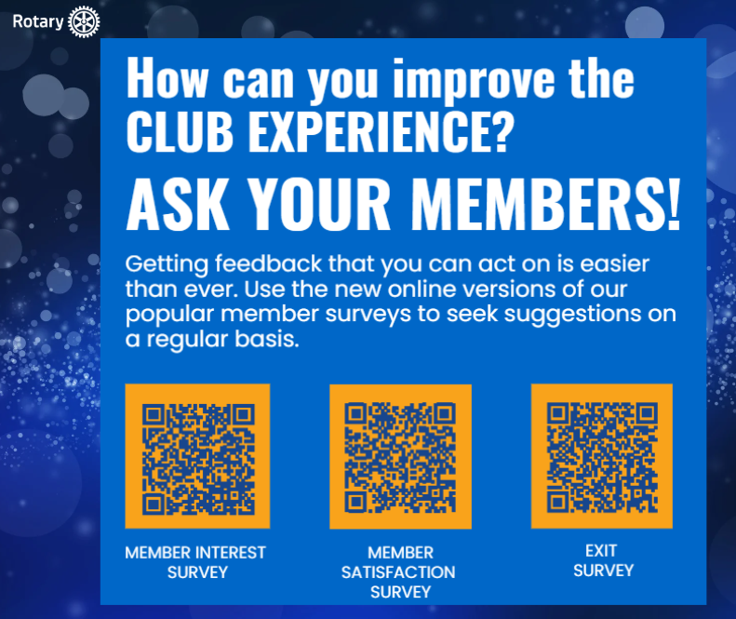 | For: Members | Getting feedback that you can act on is easier than ever. Use the new online versions of our popular member surveys to seek suggestions on a regular basis.
 | Any time  For: Members | Share the gift of Rotary with your friends, family, neighbors, and acquaintances and invite them to a Rotary activity. Tell them why you joined and let them know about the connections, impact, and growth that they can gain through Rotary. Visit our Membership Society virtual gallery to view the members who have sponsored 25 or more members into Rotary. https://my.rotary.org/en/membership-society/recognition
 | Any time  For: Members | Each of us was given an extraordinary gift when we were proposed for membership in Rotary. Extend that gift to others by visiting the Member Center in My Rotary and referring a new member. https://my.rotary.org/en/member-center
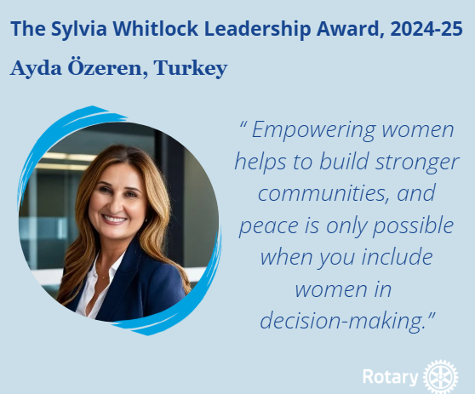 | 11 Mar 2025 or later  For: Members and general public | Congratulations to this year’s Sylvia Whitlock Leadership Award recipient  The Sylvia Whitlock Leadership Award is given every year to a Rotary Club member - regardless of gender and Rotary tenure - who has actively contributed to the advancement of women in Rotary. The award for this year has been presented to Ayda Özeren, a past district governor from Izmir, Turkey, and a member of the Rotary club of Izmir-Gündogdu. Özeren’s work as an author, mediator, and professional speaker has uplifted women and girls in Rotary and beyond. Learn more about her and see a list of previous recipients as Rotary celebrates International Women’s Day on 8 March. https://www.rotary.org/en/sylvia-whitlock-leadership-award-gallery
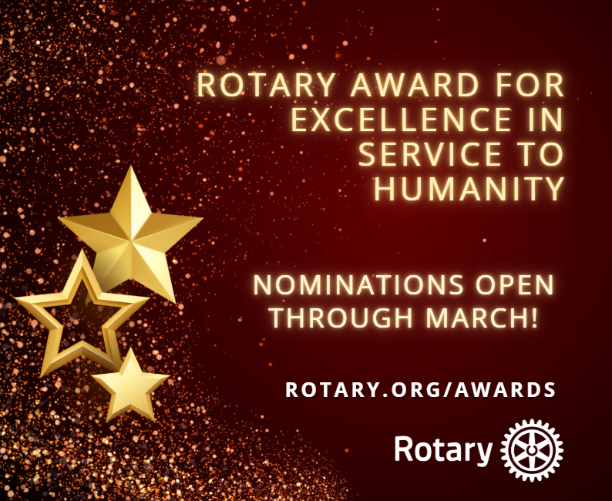 | Opens March 1  For: Members | Rotary’s Award for Excellence in Service to Humanity – nomination period open during March  Rotary’s Award for Excellence in Service to Humanity Recognizes non-Rotarians and non-Rotaractors, including partners and spouses of these members, who have demonstrated exemplary humanitarian service in accord with Rotary’s ideals. District governors may nominate one candidate from their districts to receive this award each year by completing an online nomination form between 1-31 March. Candidates will be reviewed and those selected will receive an engraved crystal and lapel pin. If you know anyone you think would qualify, contact your governor and encourage them to recognize them with a nomination. https://rotary.qualtrics.com/jfe/form/SV_6VV04kyEKGhyQDz
 | For: Members and general public | Satellite clubs are a great way for a small group to form their ideal Rotary experience. Whether a small group of Rotary members want to try something new, or some prospective members prefer something different, forming a satellite club can offer an easy and affordable solution. Satellite clubs need fewer members to start and have the support of a sponsor club. Learn more in the recently updated Guide to Satellite Clubs. https://my-cms.rotary.org/en/document/guide-satellite-clubs
 | This could go out a month or so before Convention to prompt registrants to print some before traveling.  For: Members | Promote Rotary and its benefits in your community using these resources:  The What’s Rotary? wallet card is great to share when you meet someone who’s curious about Rotary. https://my-cms.rotary.org/en/document/whats-rotary-wallet-card  You can print the prospective member flyer to distribute in your community. https://my-cms.rotary.org/en/document/prospective-member-flyer
 | For: Members and general public | Join the Rotary Positive Peace Academy. In this free training course, discover the strategies and tools that can help individuals, members, cities and nations to build and sustain peace. https://www.positivepeace.academy/rotary
 | The 2026-27 Rotary Peace Fellowship application is available online through 15 May 2025.  For: Members and general public | Join a global network of over 1,800 Rotary Peace Fellows making a difference in more than 140 countries. Each year, Rotary awards fully funded fellowships to peace and development leaders from around the world to study at one of our peace centers. Learn more and apply: https://on.rotary.org/3kUYAKv
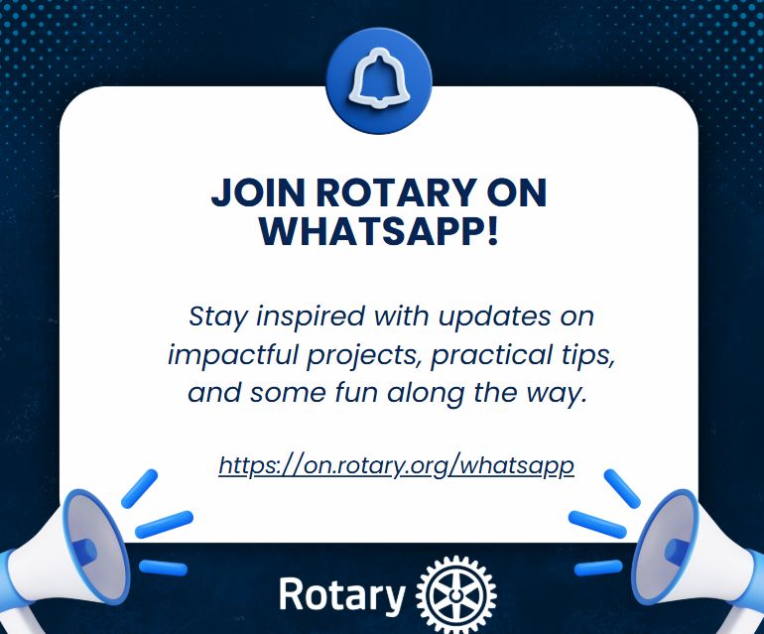 | For: Members | Rotary is now on WhatsApp! We can’t wait to connect with you Stay inspired with updates on impactful projects, practical tips, and some fun along the way. If WhatsApp is your go-to, it’s now easier than ever to keep up with all things Rotary. See you there?  Subscribe https://on.rotary.org/whatsapp
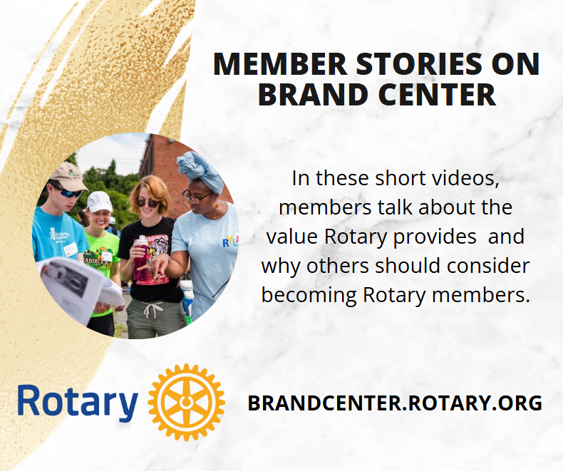 | For: Members | New testimonial campaign is live and on the Brand Center! A new Rotary promotional campaign featuring videos of diverse members sharing personal stories about how Rotary helps them further their passions and professions debuted in January. The testimonial campaign aims to expand our reach and deepen the public’s understanding of the many ways Rotary adds value to members’ lives. We’ll add more examples showcasing members’ stories from around the world as the campaign progresses. These dynamic videos can be downloaded from the Brand Center. https://brandcenter.rotary.org/en-us/search?q=member&tab=0&tt_lang=EN&dt_lang=EN&dt_campaign=Member+testimonials
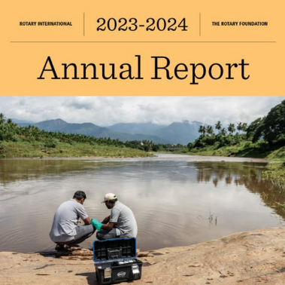 | For: Members and general public | Rotary is about the power to connect, partner, and create change. From July 2023 through July 2024, we connected, partnered, and worked to Created Hope in the World by addressing mental health and strengthening our commitment to End Polio Now. What does your club hope to accomplish in the coming year? Find our 2023–2024 annual report here: https://on.rotary.org/3E2PMf2

